Chapter 5: Using the Debugger

At the end of this chapter you should understand how to use the WICED debugging hardware including the UARTs (PUART and HCI UART) as well as the ARM debugging port. You should also have a basic understanding of WICED Debug Trace, HCI Commands, WICED HCI commands as well as using a Terminal, Client Control, BTSPY and the Eclipse Debugger.

5.1 WICED Chips & the Architecture of HCI 2

5.1.1 HCI 2

5.2 UART Debugging 4

5.2.1 Architecture 4

5.2.2 Debugging Traces 5

5.2.3 WICED HCI & the Client Control Utility 6

5.2.4 Using BTSpy & the Client Control to view HCI commands 11

5.3 Debugging Via the ARM Debug Port 13

5.3.1 Open OCD and Olimex Setup 15

5.3.2 Using the Debugger 16

5.4 Exercises 19

Exercise - 5.1 Use the Client Control Utility 19

Exercise - 5.2 Run BTSpy 20

Exercise - 5.3 (Advanced) Run the Debugger 22

### 

# WICED Chips & the Architecture of HCI

In many complicated systems, hierarchy is used to manage the complexity. WICED Bluetooth is no different. The WICED Bluetooth Stack is called a Stack because it is a set of blocks that have well defined interfaces. Here is a simple picture of the software system that we have been using. You have been writing code in the block called "Application". You have made API calls and gotten events from the "Attribute Protocol" and you implemented the "Generic Attribute Profile" by building the GATT Database. Moreover, you advertised using GAP and you Paired and Bonded by using the Security Manager.



## HCI

The next block to talk about is the "Host Controller Interface".

For technical and cost reasons, when Bluetooth was originally created the Radio was a separate chip from the one that was running the Application. The Radio chip took the name of Controller because it was the Radio and Radio Controller, and the chip running the Application was called the Host because it was hosting the Application.

The interface between the Host and the Controller was typically UART or SPI. The data flying over that serial connection was formatted in Bluetooth SIG specific packets called "HCI Packets".

By standardizing the HCI interface, it allowed big application processors (like those exiting in PCs and cellphones) to interface with Bluetooth. As time went by the Host and Controller have frequently merged into one chip (e.g. CYW20819), however the HCI interface persists even though both sides may be physically on the same chip. In this case, the HCI layer is essentially just a pass-through.

Note that even on single chip Host/Controller solutions, it is still be possible to use the chip in Controller mode with an HCI interface. For example, when the CYW20819 is used in Linux applications, it is booted in Controller mode and the Stack runs in Linux. Likewise, when the chip is put into recovery mode to do programming, it boots as a Controller.



In some devices, the WICED Bluetooth Stack can be split into a "Host" and a "Controller" part. For example, the PSoC 6 and 4343W Combo Radio is a 2-chip solution that looks like this:



The HCI concept was extended by the WICED Software team to provide a means of communication between the application layer of two chips. They call this interface "WICED HCI".



# UART Debugging

## Architecture

There are typically two UARTs in the WICED Bluetooth chips: The Peripheral UART and the HCI UART.

### Peripheral UART

The Peripheral UART (PUART) is intended to be used by your Application to send/receive whatever UART data you want. On the CYW920819 this UART is attached via a USB-UART bridge to your PC.

### HCI UART

The HCI UART has four main uses:

1. Send/receive WICED HCI messages
2. Mirror HCI Commands to a PC
3. Download firmware to the Controller Stack for programming
4. Connect the Controller Stack to a Host Stack running on a PC or an Application Processor (not our use case since we have an embedded Host stack)

There are 6 types of data that are typically transmitted via the two UARTs

1. Raw data –data your Application sends/receives to the PC (or sensor) in whatever format you choose
2. Debug Traces –debugging messages from your Application
3. WICED HCI messages – Packets of data in the Cypress WICED HCI format between the PC and your Application
4. HCI Spy – a mirror of the packets of data that cross HCI in the WICED chip
5. HCI Commands – packets of data to/from the Controller and the Host running on a PC or an Application Processor (when the chip is in Controller mode)
6. Firmware – your downloaded firmware via HCI formatted packets from the PC

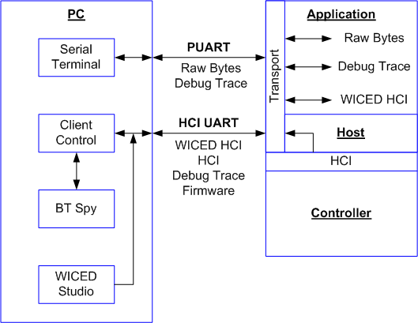

## Debugging Traces

Throughout this book, we have been using the API WICED_BT_TRACE to print out debugging messages in plain text to the PUART. It turns out that you can print your messages in two formats (plain text or WICED HCI) and you can print them to one of three places (PUART, HCI UART or None). When you called the function wiced_set_debug_uart with a parameter of wiced_debug_uart_types_t you specify a combination of destination UART and formatting.

/** Debug trace message destinations. Used when calling wiced_set_debug_uart().*/

**typedef** **enum**

{

*WICED_ROUTE_DEBUG_NONE* = 0x00, /**< No traces */

*WICED_ROUTE_DEBUG_TO_WICED_UART*, /**< send debug strings in formatted WICED HCI messages over

HCI UART to ClientControl or MCU */

*WICED_ROUTE_DEBUG_TO_HCI_UART*, /**< send debug strings as plain text to HCI UART, used by

default if wiced_set_debug_uart() not called */

*WICED_ROUTE_DEBUG_TO_DBG_UART*, /**< Deprecated */

*WICED_ROUTE_DEBUG_TO_PUART* /**< send debug strings as plain text to the peripheral uart

(PUART) */

}wiced_debug_uart_types_t;

Notice that some of the combinations are not valid. For instance, you cannot print WICED HCI messages to the PUART. You should be careful about the enumeration names as they can be a little bit confusing.

Not that this configuration is just for the WICED_BT_TRACE messages. WICED HCI messages are sent/received using a different mechanism that we will discuss next. Often you may want to send WICED_BT_TRACE messages to the PUART while using the HCI UART for WICED HCI messages, as you'll see.

## WICED HCI & the Client Control Utility

### WICED HCI

WICED HCI is a packet-based format for PC applications to interact with the Application in a WICED Bluetooth device. WICED HCI packets have 3 standard fields plus an optional number of additional bytes for payload. The packet looks like this:

* 0x19 – the initial byte to indicate a WICED HCI packet
* 2-byte little endian Opcode consisting of a 1-byte Control Group (a.k.a. Group Code) and a 1-byte Sub-Command (a.k.a. Command Code)
* A 2-byte little endian length of the additional bytes
* An optional number of additional bytes for payload

The Control Group is one of a predefined list of categories of transactions including Device=0x00, BLE=0x01, GATT=0x02, etc. These groups are defined in hci_control_api.h. This can be found in the WICED SDK under include/common. Each Control Group has one or more optional Sub-Commands. For instance, the Device Control Group has Sub-Commands Reset=0x01, Trace Enable=0x02, etc.

The Control Group plus the Sub-Command together is called a "Command" or an "Opcode" and is a 16-bit number. For example, Device Reset = 0x0001. In the actual data packet, the Opcode is represented little endian. For example, the packet for a Device Reset = 01 00 00 00.

### Transport Configuration

You will use this information in Exercise - 5.1

To send and receive WICED HCI messages you need to configure the transport system for the HCI UART. To do this you need to do the following things:

1. Include wiced_transport.h and hci_control_api.h.
2. Declare a pointer to a wiced_transport_butter_pool_t.
3. Create a global structure of type wiced_transport_cfg_t which contains the HCI UART configuration including the size of the receive and transmit buffers, a pointer to a status handler function, a pointer to the RX handler function and a pointer to the TX complete callback function (if needed).
4. Call wiced_transport_init (with a pointer to your configuration structure).
5. Call wiced_transport_create_buffer_pool to create buffers for the transport system to use.
6. Create the HCI RX handler function and TX handler function (if needed).

Each of these are shown below with examples.

#### Includes

**#include** "wiced_transport.h"

**#include** "hci_control_api.h"

#### Transport Buffer Pool Pointer

Add a global pointer to a wiced_transport_butter_pool_t like this:

**static** wiced_transport_buffer_pool_t* transport_pool = NULL;

#### Transport Configuration Structure

An example transport configuration structure for HCI is shown below. The default baud is 3,000,000. In this example, there is no HCI TX handler implemented so it is specified as NULL.

/*******************************************************************

* Transport Configuration

******************************************************************/

**#define** TRANS_UART_BUFFER_SIZE 1024

**#define** TRANS_UART_BUFFER_COUNT 2

**const** wiced_transport_cfg_t transport_cfg =

{

.type = *WICED_TRANSPORT_UART*, /**< Wiced transport type. */

.cfg.uart_cfg =

{

.mode = *WICED_TRANSPORT_UART_HCI_MODE*, /**< UART mode, HCI or Raw */

.baud_rate = HCI_UART_DEFAULT_BAUD /**< UART baud rate */

},

.rx_buff_pool_cfg =

{

.buffer_size = TRANS_UART_BUFFER_SIZE, /**< Rx Buffer Size */

.buffer_count = TRANS_UART_BUFFER_COUNT /**< Rx Buffer Count */

},

.p_status_handler = NULL, /**< Wiced transport status handler.*/

.p_data_handler = hci_control_process_rx_cmd, /**< Wiced transport receive data handler. */

.p_tx_complete_cback = NULL /**< Wiced transport tx complete callback. */

#### };

#### Transport Init and Buffer Pools

Once the structure is setup, you have to initialize the transport and create buffer pools. This is commonly done right at the top of application_start.

/* Initialize the transport configuration */

wiced_transport_init( &transport_cfg );

/* Initialize Transport Buffer Pool */

transport_pool = wiced_transport_create_buffer_pool ( TRANS_UART_BUFFER_SIZE,

TRANS_UART_BUFFER_COUNT );

#### RX Handler

Your application is responsible for handling the HCI commands sent to your application. When a new command is sent, your RX handler function will be called. This function should just make sure that a legal packet has been sent to it, and then do the right thing.

The example RX handler below just verifies the packet is legal, extracts the Command (i.e. Opcode), optional data length, and optional payload. It then prints out a message and sends back a message to the host formatted as a WICED HCI command called HCI_CONTROL_EVENT_COMMAND_STATUS with a data value of HCI_CONTROL_STATUS_UNKNOWN_GROUP.

/* Handle Command Received over Transport */

uint32_t **hci_control_process_rx_cmd**( uint8_t* p_data, uint32_t len )

{

uint8_t status = 0;

uint8_t cmd_status = HCI_CONTROL_STATUS_SUCCESS;

uint16_t opcode = 0;

uint8_t* p_payload_data = NULL;

WICED_BT_TRACE("hci_control_process_rx_cmd : Data Length '%d'\n", len);

// At least 4 bytes are expected in WICED Header

**if** ((NULL == p_data) || (len < 4))

{

WICED_BT_TRACE("Invalid Parameters\n");

status = HCI_CONTROL_STATUS_INVALID_ARGS;

}

**else**

{

// Extract OpCode and Payload data from little-endian byte array

opcode = (uint16_t)( ((p_data)[0] | ((p_data)[1] << 8)) );

p_payload_data = &p_data[**sizeof**(uint16_t)*2];

// **TODO**: Process received HCI Command based on its Opcode

// (see 'hci_control_api.h' for additional details)

**switch** (opcode)

{

**default**:

// HCI Control Group was not handled

cmd_status = HCI_CONTROL_STATUS_UNKNOWN_GROUP;

wiced_transport_send_data(HCI_CONTROL_EVENT_COMMAND_STATUS, &cmd_status,

**sizeof**(cmd_status));

**break**;

}

}

// When operating in WICED_TRANSPORT_UART_HCI_MODE or WICED_TRANSPORT_SPI,

// application has to free buffer in which data was received

wiced_transport_free_buffer( p_data );

p_data = NULL;

**return** status;

}

#### WICED HCI TX

Inside of your application you can send WICED HCI messages to the host by calling wiced_transport_send_data with the 16-bit opcode, a pointer to the optional data and the length of the data. In the situation where you have the WICED_BT_TRACE setup to send WICED HCI Trace messages, when you call the WICED_BT_TRACE API all it does is format your data, then it calls this:

sprintf(string,…);

wiced_transport_send_data(HCI_CONTROL_EVENT_WICED_TRACE, &string, strlen(string));

For example, if you call *WICED_BT_TRACE(“abc”);* it will send *19 02 00 03 00 41 42 43*

19 = HCI Packet

02 = Command Code (Trace)

00 = Group Code (Device)

03 00 = Number of additional bytes (little endian)

41 = 'a'

42 = 'b'

43 = 'c'

### Client Control Utility (Part 1)

The *Client Control* utility is a PC based program that connects to the HCI UART port and gives you a GUI to send and receive WICED HCI messages. It can be launched from the Quick Panel in ModusToolbox. The source code is also provided - it can be found in <install_dir>/libraries/bt_20819A1-1.0/compontents/BT-SDK/common/client_control.

Once you open the tool, select the appropriate COM port (make sure to choose the HCI UART, not the PUART) and set the Baud Rate – the default for HCI UART is 3,000,000. Then click on Open Port to make the connection.

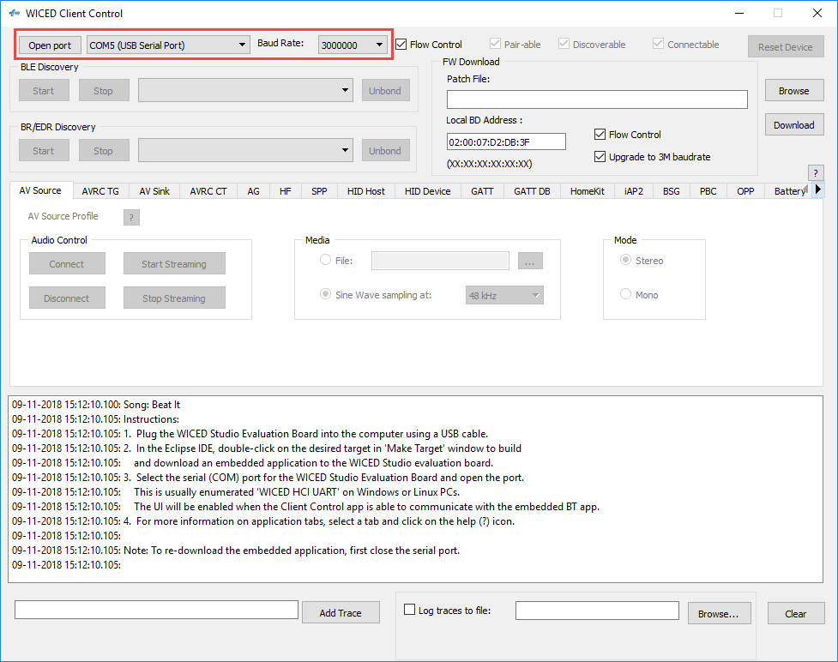

The GUI has buttons and text boxes that make sense for each WICED HCI Control group. For example, in the picture below the “GATT Profile” tab is selected which gives you logical access to the commands in the GATT_COMMAND control group such as Start Adverts, Discover Services, Connect, etc. Return messages will show up in the log window at the bottom.

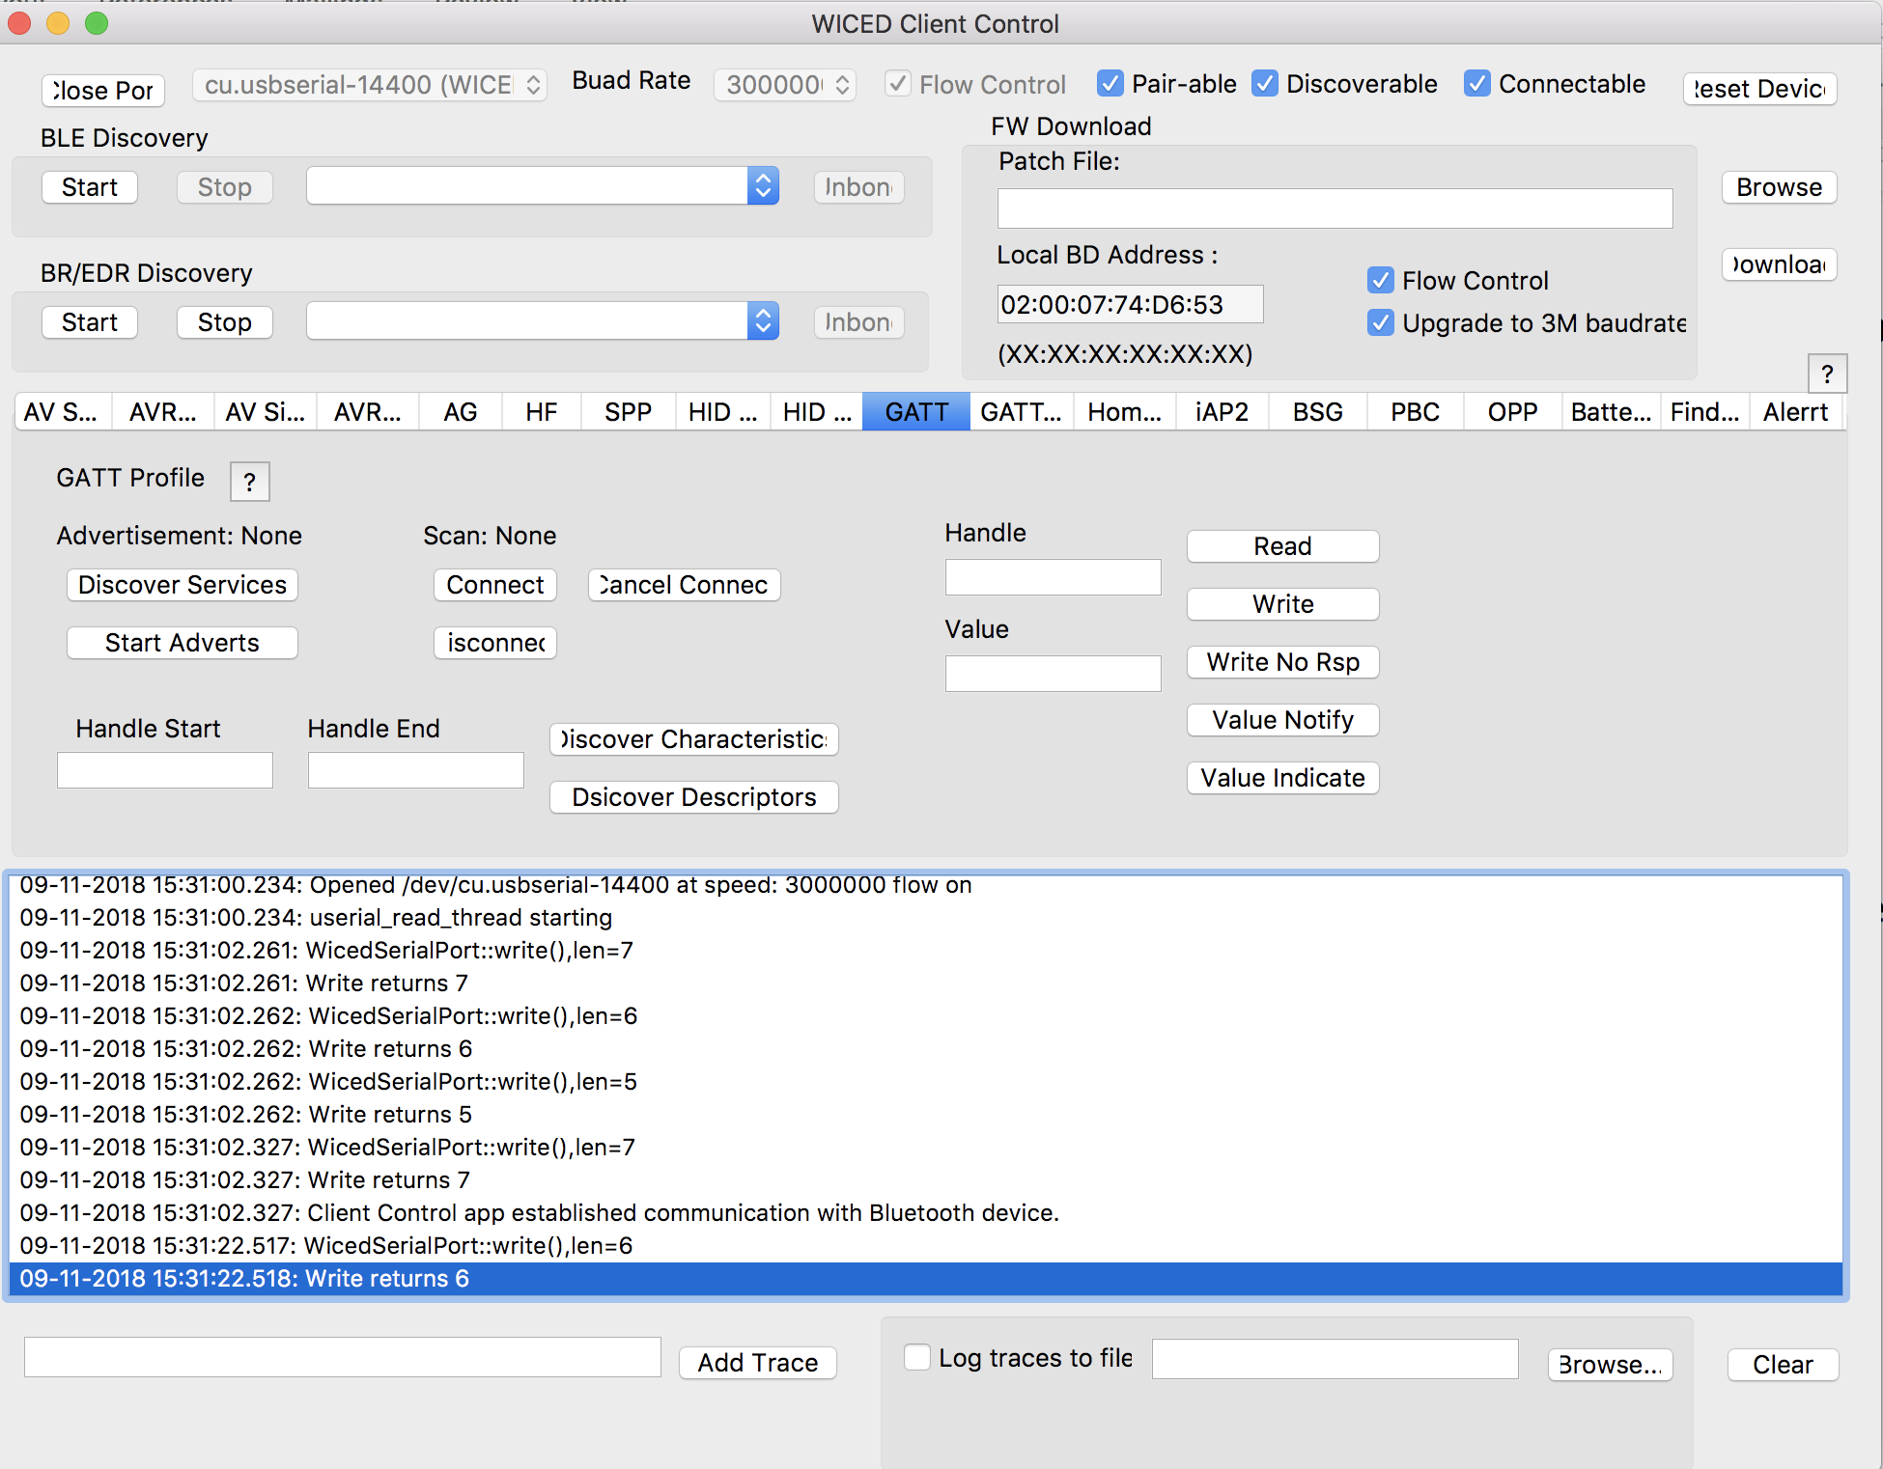

## Using BTSpy & the Client Control to view HCI commands

You will try this out in Exercise - 5.2.

you are trying to figure out what in the world is going on between your Host API calls and the Controller, BTSpy is a very useful utility. Note that these calls may be "virtual". That is, they may be calls between the Host and Controller Stacks on a single device such as the CYW20819.

### Introduction

The *BTSpy* trace option provides an advantage over the UART options. Namely, applications may configure the Stack to generate Bluetooth protocol trace messages showing all activity between the host and the controller over the virtual HCI interface embedded in the CYW20819 device. The Bluetooth protocol trace messages will be encoded into WICED HCI message packets and sent along with application trace messages from *WICED_BT_TRACE()*, which can be displayed by the *BTSpy* utility. You can then view the application trace messages in sequence with the corresponding Bluetooth protocol trace messages.

BTSpy connects into the Client Control Utility that we discussed previously. So, the setup is exactly the same with one exception. Namely, you will want to reroute debug trace messages to WICED_ROUTE_DEBUG_TO_WICED_UART instead of to WICED_ROUTE_DEBUG_TO_PUART. That way, you will see both your application trace messages and messages from the virtual HCI port in the same window.

### Project Configuration

To configure the stack to generate Bluetooth protocol trace messages, applications must define a callback function and register it with the stack using the *wiced_bt_dev_register_hci_trace()* API. This function should be called in the BTM_ENABLED_EVT once the Bluetooth stack has been initialized. For example:

wiced_bt_dev_register_hci_trace(app_btspy_callback);

The callback function implementation should call the *wiced_transport_send_hci_trace()* API with the data received in the callback. The callback function looks like this:

**void** app_btspy_callback(wiced_bt_hci_trace_type_t type, uint16_t length, uint8_t* p_data)

{

wiced_transport_send_hci_trace( transport_pool, type, length, p_data );

}

### Viewing Traces

To view application and Bluetooth protocol traces in *BTSpy*:

1. Setup the Transport for HCI just like in the previous section.
2. Create and register a function for Bluetooth protocol trace messages.
3. Build and download the application to the evaluation board.
4. Press **Reset** (SW2) on the WICED evaluation board to reset the HCI UART after downloading and before opening the port with *ClientControl*. This is necessary because the programmer and HCI UART use the same interface.
5. Run the *ClientControl* utility fromthe Quick Panel in ModusToolbox.
6. In the *ClientControl* utility, select the HCI UART port in the UI, and set the baud rate to the baud rate used by the application for the HCI UART (the default baud rate is 3000000).
7. Run the BTSpy utility from the Quick Panel in ModusToolbox.
8. In the ClientControl utility, open the HCI UART COM port by clicking on "Open Port".
   1. Note: The HCI UART is the same port used for programming, so you must disconnect each time you want to re-program.
   2. Note: If you reset the kit while the ClientControl utility has the port open, the kit will go into recovery mode (because the CTS line is asserted). Therefore, you must disconnect the ClientControl utility before resetting the kit.
9. View trace messages in the *BTSpy* window.
   1. Lines in black are standard WICED_BT_TRACE messages, blue are messages sent over HCI and green are messages received over HCI.

# Debugging Via the ARM Debug Port

Hardware debugging on WICED Bluetooth devices can done using an OpenOCD supported JTAG probe. However, if your device has an active BLE connection it will drop the connection when the CPU is halted in the debugger (after the connection timeout). Therefore, for BLE applications it is more common to use BTSpy for debugging rather than a hardware debugger.

In this section we will describe two different sets of hardware: a Segger J-Link debug probe and an Olimex ARM-USB-TINY-H debug probe with an additional ARM-JTAG-SWD adapter. In both cases, an adapter to convert the 20-pin connector to the small footprint 10-pin connector may be needed depending on the debug connector available on the kit. The tables below list the hardware required for each option:

|  |  |  |  |
| --- | --- | --- | --- |
| **Option 1** | **Manufacturer** | **Part Number** | **Description** |
| Segger J-Link | Segger | 8.08.00 J-Link Base | Debug probe |
| Olimex | ARM-JTAG-20-10 | 20-10 pin adapter |
| **Option 2** | **Manufacturer** | **Part Number** | **Description** |
| Olimex | Olimex | ARM-USB-TINY-H | Debug probe |
| Olimex | ARM-JTAG-SWD | SWD – JTAG adapter |
| Olimex | ARM-JTAG-20-10 | 20-10 pin adapter |

Pictures showing the debugging setup for each configuration are shown here:

 

The process to setup and run the debugger is described in detail in a guide titled "Hardware Debugging for CYW207xx and CYW208xx". This guide is available from ModusToolbox, so that information is not repeated here. To access the guide from ModusToolbox select one of the following:

**Quick Panel > Documents Tab > ModusToolbox Documentation Index**

**Help > ModusToolbox General Documentation > ModusToolbox Documentation Index**

From the browser window that opens, select this item from the Bluetooth Documentation section:

**Hardware Debugging for WICED devices**

A few important notes:

1. You should follow the instructions in section 2 of the guide after completing sections 3 and 4. That is, you should have a kit programmed with a debug enabled application when you setup the debug probe.
2. The instructions for using OpenOCD with the Olimex debug probe (section 2.3 of the hardware debugging guide) are not sufficiently detailed. Therefore, additional details are provided in the next section of this manual.
3. The SWD pins are not enabled in the platform by default. To use the debugger, enable SWD and set the pins to P2 (SWD_CLK) and P3 (SWD_IO) in the configurator.
   1. Once you add the pins, you must open the wiced_platform.h file for the application and add two additional pins to the wiced_platform_pins list (11 and 12 were added):

//! List of pins available on the platform

**enum** wiced_platform_pins

{

*PLATFORM_GPIO_0*,

*PLATFORM_GPIO_1*,

*PLATFORM_GPIO_2*,

*PLATFORM_GPIO_3*,

*PLATFORM_GPIO_4*,

*PLATFORM_GPIO_5*,

*PLATFORM_GPIO_6*,

*PLATFORM_GPIO_7*,

*PLATFORM_GPIO_8*,

*PLATFORM_GPIO_9*,

*PLATFORM_GPIO_10*,

*PLATFORM_GPIO_11*,

*PLATFORM_GPIO_12,*

*PLATFORM_GPIO_MAX_PINS*

};

1. There is a DIP switch (SW9) that controls routing of P2 and P3 to the debug header. The switches must be in the OFF position to enable the debug header connections.
   1. P2 and P3 route to Arduino header pins when the switches are in the ON position.
2. The BUSY_WAIT_TILL_MANUAL_CONTINUE_IF_DEBUG_ENABLED macro will cause execution to wait in a loop until the JTAG debugger resumes execution. Therefore, the board will not show any activity after programming or reset until execution is resumed by the user from inside the debugger.
3. If you have trouble re-programming after using debugging, try the following:

* Hold the "Recover" button on the kit.
* Press and release the "Reset" button.
* Release the "Recover" button.
* Attempt to program again.

1. If you get an error message when launching the debugger about another instance already running, open the task manager (Ctrl-Alt-Del) and end any tasks named arm-none-eabi-gdb.exe.

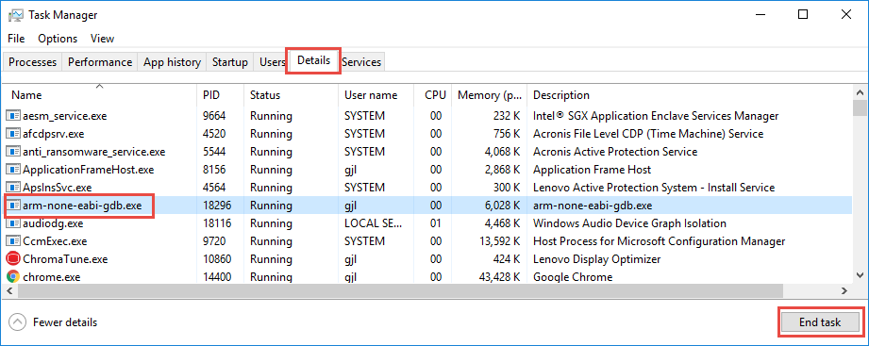

## Open OCD and Olimex Setup

The following supplements the instructions in section 2.3 of the Hardware Debugging for CYW207xx and CYW208xx guide.

1. OpenOCD is installed as part of ModusToolbox so you can skip this step.
2. Configuration files for the CYW20819EVB-02 have been created for the class and are provided with the class files. To install them, you must copy the following two files:

* Copy file from:

<class_files>/WBT101_Files/Software_Tools/Olimex/Debug_Config_Files/board/CYW920819EVB-02.cfg

to:

<ModusToolbox_Install>/tools/openocd-2.1/scripts/board/CYW920819EVB-02.cfg

* Copy file from:

<class_files>/WBT101_Files/Software_Tools/Olimex/Debug_Config_Files/target/CYW20819.cfg

to:

<ModusToolbox_Install>/tools/openocd-2.1/scripts/target/CYW20819.cfg

1. Follow the remaining steps (3-7) as described in the hardware debugging guide.

## Using the Debugger

Once you have configured the firmware, programmed the board, and started the debugger, the application will sit in the BUSY_WAIT_TILL_MANUAL_CONTINUE_IF_DEBUG_ENABLED loop. Start execution (if it isn't already running) and then pause to make sure the firmware is inside the loop. In the "Variables" tab in the Quick Panel, erase the entire value for *spar_debug_contine*, enter a new value of 1 and press Enter. Once you have changed the value of *spar_debug_continue*, you can resume execution and the program will go beyond the busy wait loop.

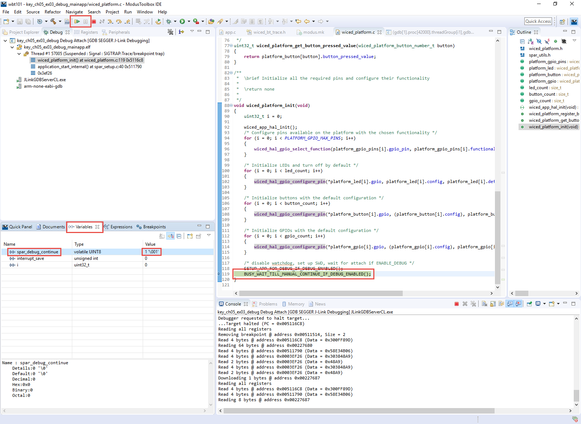

When program execution is paused, you can add breakpoints to halt at specific points in the code. To add a breakpoint, open the source file (such as 02_blinkled.c), click on the line where you want a breakpoint and double-click in the bar to the left of the code window or right-click in that area and select "Toggle Breakpoint". An enabled breakpoint is a blue circle with a black checkmark next to it.

Click the "Resume" button (shown in the figure above) to resume execution. The program will halt once it reaches the breakpoint.

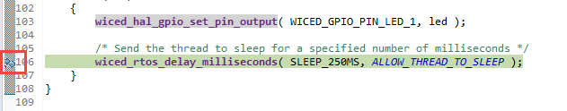

Once a thread suspends due to a breakpoint you will see that line of code highlighted in green as shown above and you will see that the thread is suspended due to the breakpoint in the debug window as shown below.

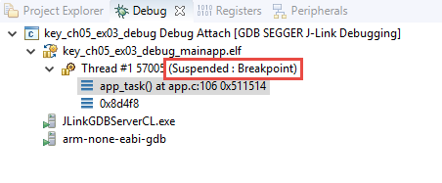

You can enable or disable breakpoints by double clicking on the green circle next to the line in the source code or from the "Breakpoints" tab in the Quick Panel.

If breakpoints are created prior to starting the current debug session, they may not be associated with the current thread and will be indicated with a blue circle without a check mark. To enable the breakpoints in the current thread, right-click the desired breakpoint and select "Breakpoint Properties…" Click on "Filter" and make sure the boxes are checked as shown below.

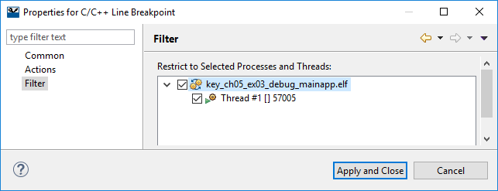

If you do not see any breakpoints in the Breakpoints window, turn off the "Show Breakpoints Supported by Selected Target" button as shown below.

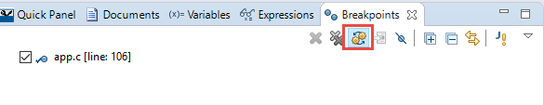

Click the red "Terminate" button to stop debugging. Once debugging stops, you will likely want to switch back to the Project Explorer tab instead of the Debug tab. Alternately, you can use the menu item Window > Perspective > Reset Perspective to reset the ModusToolbox perspective to the default window sizes and placement.

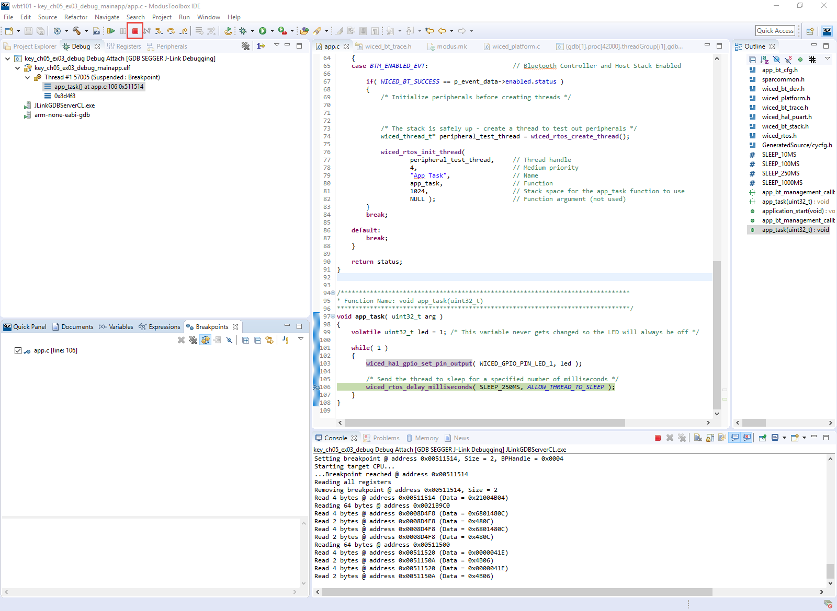

A few additional notes on debugging:

1. Single stepping through code requires a free breakpoint.
2. There are two hardware breakpoints available.
3. Only hardware breakpoints can be used for ROM opcodes.
4. The device uses both ROM and RAM for firmware. For example, many WICED API functions will call into ROM code for support.
5. Source code and symbols are not provided for ROM and some patch library areas. Source code debugging will be limited to the code for which you have sources.
6. Typically, the step command is ignored by GDB if a breakpoint is not available.

# Exercises

* 1. Use the Client Control Utility

### Introduction

In this project, you will add the ability to start and stop advertising using WICED HCI messages from the Client Control utility.

### Project Creation

1. Create a new application called **ch05_ex01_hci** using the modus.mk file in templates/CYW920819EVB/ch05_ex01_hci.
2. Launch the Change Applications Settings dialog and set BT_DEVICE_ADDRESS = random.
3. Open the Device Configurator and then the Bluetooth Configurator.
   1. Change the device name to <inits>_hci.
   2. Save edits and close the configurators.
4. Review the steps in the Transport Configuration section of this chapter and add in the necessary code to support WICED HCI.
   1. Hint: A TX handler is not required for this exercise.
5. Create an RX handler and add a case to the opcode switch statement to handle the *_ADVERTISE command.
   1. Hint: Refer to the file include/common/hci_control_api.h to find the full name of the opcode for the *_ADVERTISE command.
   2. Hint: The payload will be 0 to stop advertisements and 1 to start advertisements.
   3. Hint: Use the function wiced_bt_start_advertisements with either BTM_BLE_ADVERT_OFF or BTM_BLE_ADVERT_NONCONN_HIGH depending on whether the first byte of the payload is 0 or 1.
6. (Advanced): Update the Bluetooth Stack Management callback to send a WICED HCI status message when the advertising state changes.
   1. Hint: Use the wiced_transport_send_data function and the same ADVERTISE code used above. Note that you must send a value of either 0 (stopped) or 1 (started) even though the callback will send other values depending on the type of advertising (e.g. 3 for high duty connectable and 4 for low duty connectable. If you send a value other than 0 or 1, the Client Control utility will crash.

### Testing

1. Program the project to the kit.
   1. Hint: If you have the port open in Client Control, you will have to close the port before being able to program again because programming and Client Control both use the WICED HCI port.
2. Open the Client Control program from the Quick Panel and connect to the WICED HCI port.
3. Open CySmart and scan for devices. Note that your device does not appear.
4. In Client Control, switch to the GATT tab and click on Start Adverts. Look at the return message if you implemented the status message.
5. Verify that your device now appears in CySmart.
6. In Client Control click on Stop Adverts and look at the return message. Stop and Re-start the scan in CySmart. Note that your device no longer appears.
   1. Run BTSpy

In this project you will use BTSpy to look at Bluetooth protocol trace messages. This is covered in 5.2.4

### Project Creation

1. Create a new application called **ch05_ex02_btspy** using the modus.mk file in templates/CYW920819EVB/ch05_ex01_hci.
2. Launch the Change Applications Settings dialog and set BT_DEVICE_ADDRESS = random.
3. Open the Device Configurator and then the Bluetooth Configurator.
   1. Change the device name to <inits>_btspy.
   2. Save edits and close the configurators.
4. Setup the transport configuration just like the last exercise, but this time, you can specify NULL for the receive data handler since we won't deal with any incoming HCI commands in our application.
   1. Hint: Add includes for the two header files, create a variable for transport_pool, create/setup the transport_cfg structure, and in application_start, initialize transport and create buffer pools.
5. Create a BTSpy callback function and register it in the BTM_ENABLED_EVT event.
6. Route the debug messages to WICED_ROUTE_DEBUG_TO_WICED_UART instead of WICED_ROUTE_DEBUG_TO_PUART. This will mean that Bluetooth trace messages and WICED_BT_TRACE messages will go to the HCI UART using WICED HCI formatting.
7. In the app_bt_cfg.c file, change the low duty cycle advertisement duration to 0 so that advertising doesn't stop after 60 seconds.

### Programming and Setup

1. Build and download the application to the kit.
2. Press **Reset** (SW2) on the WICED evaluation board to reset the HCI UART after downloading and before opening the port with *ClientControl*. This is necessary because the programmer and HCI UART use the same interface.
3. Run the *ClientControl* utility from the Quick Panel. Select the HCI UART port, and set the baud rate to the baud rate used by the application for the HCI UART (the default baud rate is 3000000). Do NOT open the port yet.
4. Run the BTSpy utility from the Quick Panel.
   1. Hint: If your computer has a Broadcom WiFi chip, it will show lots of messages that are from your computer instead of from your kit. To disable these messages, you will need to temporarily disable Bluetooth on your computer.
5. In the ClientControl utility, open the HCI UART COM port by clicking on "Open Port".

### Testing

1. If you want to capture the log from BTSpy to a file, click on the "Save" button (it looks like a floppy disk). Click Browse to specify a path and file name, click on "Start Logging", and then click on "OK".
   1. Hint: If you want to include the existing log window history in the file (for example if you forgot to start logging at the beginning) check the box "Prepend trace window contents" before you start logging.
2. Use CySmart to connect to the device and observe the messages in the BTSpy window.
3. Once paring is complete, click the "Notes" button (it looks like a Post-It note), enter "Pairing Completed" and click OK. Observe that a note is added to the trace window.
4. Read the Button Characteristic and observe the messages.
5. Add a note that says " Button Characteristic Read Complete"
6. Disconnect from the device.
7. Once you are done logging, click on the "Save" button, click on "Stop Logging", and then click on "OK".
   1. (Advanced) Run the Debugger

In this exercise you will setup and run the debugger using an Olimex debug probe. You will then use the debugger to change the value of a variable that controls an LED on the shield.

1. Read the "Hardware Debugging for CYW207xx and CYW208xx" guide.
2. Create a new application called **ch05_ex03_debug** using the modus.mk file in templates/CYW920819EVB/ch05_ex03_debug.
3. Open the "Change Application Settings" dialog and verify that ENALBE_DEBUG is set to 1.
4. Open the configurator and:
   1. Enable SWD
   2. Assign the SWD pins as follows:
      1. SWD_CLK: P02
      2. SWD_IO: P03
   3. Verify that the pins are configured with a Type of "Peripheral".
   4. Save changes and close the configurator.
5. Add two pins (PLATFORM_GPIO_11 AND PLATFORM_GPIO_12) to the wiced_platform_pins list in the wiced_platform.h file.
   1. Hint: This is necessary because we added 2 new pins to our platform but the platform configuration file does not define that many GPIOs by default.
6. Verify that the two switches in SW9 are in the OFF position on your kit.
   1. Hint: SW9 is the 2 position DIP switch near the 10-pin debug header.
7. Connect your kit and Olimex debugger to each other and then to USB ports on your computer.
8. Program the application to kit (<appname> Build + Program)
9. Follow the instructions to set up OpenOCD for the Olimex debugger in section 5.3.1 of this manual and section 2.3 of the hardware debugging guide.
10. Follow the instructions in the hardware debugging guide to create a GDP OpenOCD Debugging Configuration.
    1. Hint: Start on page 14 of the hardware debugging guide below the figure.
    2. Hint: The entries on the Debugger tab in the Debug Configuration can be copy/pasted from here:

Executable Path:

**${cy_tools_path:openocd}/bin/openocd**

Config Options:

**-s "${cy_tools_path:openocd}/scripts"**

**-f "${cy_tools_path:openocd}/scripts/board/CYW920819EVB-02.cfg"**

**-c "puts stderr {Started by GNU MCU Eclipse}"**

Executable Name:

**${cy_sdk_install_dir}\tools\gcc-7.2.1-1.0\bin\arm-none-eabi-gdb.exe**

1. Place a break point at the wiced_rtos_delay_milliseconds call in the app_task thread in app.c.
2. Pause execution. You should be in the BUSY_WAIT_TILL_MANUAL_CONTINUE_IF_DEBUG_ENABLED() loop.
3. Set the value of *spar_debug_contine* to 1 to get out of the initial loop.
4. Execute a few more times and notice that execution suspends at the breakpoint you added.
5. Observe that the LED does not turn on because the variable "led" never changes.
6. Change the value of the variable "led" and then re-start execution.
   1. Hint: The LED is active low.
7. Note that the LED now turns on.
8. Stop the debugger by pressing the stop button.
9. Use the menu item Window > Perspective > Reset Perspective.